4.Create a simple cloud software application for Library book reservation system for SIMATS library using any Cloud Service Provider to demonstrate SaaS
Aim:
To develop a simple cloud-based Library Book Reservation System for SIMATS Library using SaaS.
Procedure:
- Create an account in a cloud platform such as Google AppSheet.
- Create an application named SIMATS Library Book Reservation System.
- Create tables/forms for Books, Members, and Reservations.
- Add fields such as Book Title, Author, ISBN, Member ID, Reservation Date, and Status.
- Create a reservation form for students.
- Configure the system to update book availability.
- Deploy the application for online access.
IMPLIMENTATION:
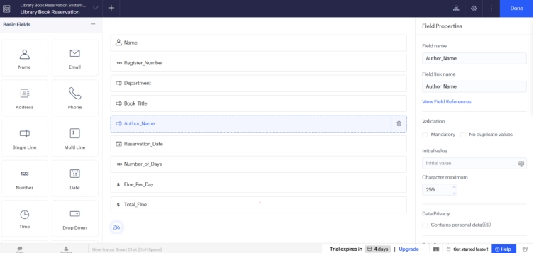
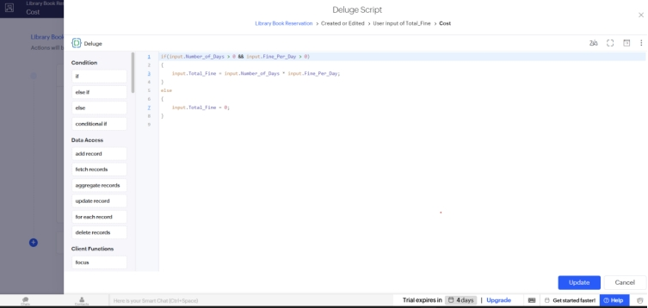
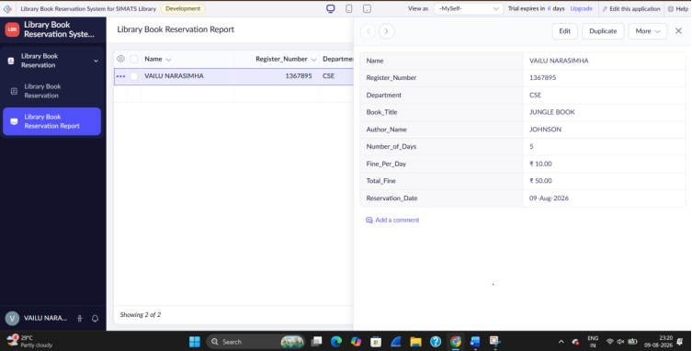
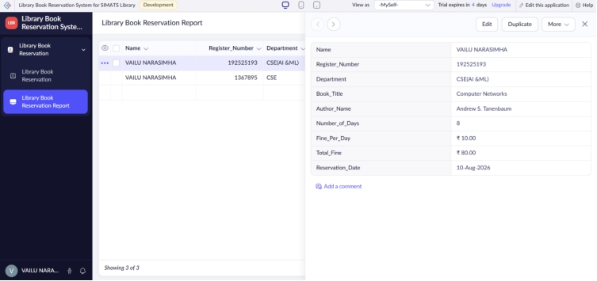
Result:
A cloud-based SIMATS Library Book Reservation System was successfully created. Students can search for books and reserve available books online, while library staff can manage reservations.

